

**Maisammaguda, Kompally, Medchal - Malkajgiri District Hyderabad - 500100, Telangana State**[**.**](http://www.mallareddyuniversity.ac.in/)[**www.mallareddyuniversity.**](http://www.mallareddyuniversity.ac.in/)

(**Telangana State Private Universities Act No. 13 of 2020 &**

**G.O.Ms. No. 14, Higher Education (UE) Department)**

Department Of Computer Science And Engineering

Mobile Application Development Project

Money Mapper

Name: Subhapreet Patro

Roll number: 2211CS010547

Yr/Sec: Group-3(III-year)

**XML Code:**

**activity_main.xml:**

<?xml version="1.0" encoding="utf-8"?>  
<androidx.constraintlayout.widget.ConstraintLayout  
 xmlns:android="http://schemas.android.com/apk/res/android"  
 xmlns:app="http://schemas.android.com/apk/res-auto"  
 android:layout_width="match_parent"  
 android:layout_height="match_parent"  
 android:padding="20dp"  
 android:background="@drawable/gradient_background">  
  
 <LinearLayout  
 android:id="@+id/title_section"  
 android:layout_width="wrap_content"  
 android:layout_height="wrap_content"  
 android:orientation="horizontal"  
 android:gravity="center_vertical"  
 android:layout_marginBottom="16dp"  
 android:layout_marginTop="150dp"  
 app:layout_constraintTop_toTopOf="parent"  
 app:layout_constraintStart_toStartOf="parent"  
 app:layout_constraintEnd_toEndOf="parent">  
  
 <ImageView  
 android:layout_width="48dp"  
 android:layout_height="48dp"  
 android:src="@drawable/ic_logo"  
 android:contentDescription="App Logo"  
 android:layout_marginEnd="10dp" />  
  
 <TextView  
 android:layout_width="wrap_content"  
 android:layout_height="wrap_content"  
 android:text="Money Mapper"  
 android:textSize="24sp"  
 android:textStyle="bold"  
 android:textColor="@color/black"/>  
 </LinearLayout>  
  
 <androidx.cardview.widget.CardView  
 android:layout_width="match_parent"  
 android:layout_height="wrap_content"  
 app:cardCornerRadius="16dp"  
 app:cardElevation="6dp"  
 android:layout_marginTop="15dp"  
 android:padding="16dp"  
 app:cardBackgroundColor="@color/white"  
 app:layout_constraintTop_toBottomOf="@id/title_section"  
 app:layout_constraintStart_toStartOf="parent"  
 app:layout_constraintEnd_toEndOf="parent">  
  
 <LinearLayout  
 android:layout_width="match_parent"  
 android:layout_height="wrap_content"  
 android:orientation="vertical"  
 android:padding="10dp">  
  
 <LinearLayout  
 android:layout_width="match_parent"  
 android:layout_height="wrap_content"  
 android:orientation="horizontal"  
 android:gravity="center"  
 android:paddingBottom="10dp">  
  
 <Spinner  
 android:id="@+id/from_currency"  
 android:layout_width="0dp"  
 android:layout_height="34dp"  
 android:layout_weight="1"  
 android:background="@drawable/spinner_background" />  
  
 <ImageView  
 android:id="@+id/swap_button"  
 android:layout_width="48dp"  
 android:layout_height="48dp"  
 android:src="@drawable/ic_exchange"  
 app:tint="@color/black"  
 android:layout_marginHorizontal="16dp"  
 android:clickable="true"  
 android:focusable="true"  
 android:contentDescription="Swap Currencies"/>  
  
  
 <Spinner  
 android:id="@+id/to_currency"  
 android:layout_width="0dp"  
 android:layout_height="34dp"  
 android:layout_weight="1"  
 android:background="@drawable/spinner_background" />  
 </LinearLayout>  
  
 <com.google.android.material.textfield.TextInputLayout  
 android:layout_width="match_parent"  
 android:layout_height="wrap_content"  
 android:hint="Enter amount"  
 android:layout_marginTop="16dp">  
  
 <com.google.android.material.textfield.TextInputEditText  
 android:id="@+id/amount_input"  
 android:layout_width="match_parent"  
 android:layout_height="wrap_content"  
 android:textColor="@color/black"  
 android:inputType="numberDecimal" />  
 </com.google.android.material.textfield.TextInputLayout>  
  
 <Button  
 android:id="@+id/convert_button"  
 android:layout_width="match_parent"  
 android:layout_height="wrap_content"  
 android:text="Convert"  
 android:textSize="16sp"  
 android:layout_marginTop="16dp"  
 android:backgroundTint="@color/primary_color"  
 android:textColor="@color/white"  
 android:padding="12dp"  
 android:drawableStart="@drawable/ic_exchange" />  
 </LinearLayout>  
 </androidx.cardview.widget.CardView>  
  
</androidx.constraintlayout.widget.ConstraintLayout>

**activity_result.xml:**

<?xml version="1.0" encoding="utf-8"?>  
<LinearLayout xmlns:android="http://schemas.android.com/apk/res/android"  
 android:layout_width="match_parent"  
 android:layout_height="match_parent"  
 android:orientation="vertical"  
 android:gravity="center"  
 android:padding="20dp"  
 android:background="@drawable/gradient_background">  
  
 <TextView  
 android:layout_width="wrap_content"  
 android:layout_height="wrap_content"  
 android:textSize="28sp"  
 android:text="Converted Amount"  
 android:textStyle="bold"  
 android:textColor="@color/black"/>  
  
 <TextView  
 android:id="@+id/result_text"  
 android:layout_width="wrap_content"  
 android:layout_height="wrap_content"  
 android:textSize="24sp"  
 android:text="Converted Amount"  
 android:textStyle="bold"  
 android:textColor="@color/black"/>  
 <RadioGroup  
 android:id="@+id/time_filter_group"  
 android:layout_width="wrap_content"  
 android:layout_height="wrap_content"  
 android:orientation="horizontal"  
 android:layout_gravity="center"  
 android:layout_marginTop="10dp"  
 android:layout_marginBottom="7dp">  
  
 <RadioButton  
 android:id="@+id/rb_1d"  
 android:layout_width="wrap_content"  
 android:layout_height="wrap_content"  
 android:text="1D"  
 android:checked="true"  
 android:textColor="@android:color/black" />  
  
 <RadioButton  
 android:id="@+id/rb_5d"  
 android:layout_width="wrap_content"  
 android:layout_height="wrap_content"  
 android:text="5D"  
 android:textColor="@android:color/black"/>  
  
 <RadioButton  
 android:id="@+id/rb_1m"  
 android:layout_width="wrap_content"  
 android:layout_height="wrap_content"  
 android:text="1M"  
 android:textColor="@android:color/black"/>  
  
 <RadioButton  
 android:id="@+id/rb_1y"  
 android:layout_width="wrap_content"  
 android:layout_height="wrap_content"  
 android:text="1Y"  
 android:textColor="@android:color/black"/>  
  
 <RadioButton  
 android:id="@+id/rb_5y"  
 android:layout_width="wrap_content"  
 android:layout_height="wrap_content"  
 android:text="5Y"  
 android:textColor="@android:color/black"/>  
 </RadioGroup>  
  
 <com.github.mikephil.charting.charts.LineChart  
 android:id="@+id/line_chart"  
 android:layout_width="match_parent"  
 android:layout_height="310dp"  
 android:layout_marginTop="20dp"  
 android:background="@android:color/transparent"/>  
  
 <Button  
 android:id="@+id/back_button"  
 android:layout_width="wrap_content"  
 android:layout_height="wrap_content"  
 android:text="Go Back"  
 android:layout_marginTop="20dp"  
 android:backgroundTint="@color/primary_color"  
 android:textColor="@color/white"/>  
</LinearLayout>

**Java Code:**

**MainActivity.java:**

package com.example.currencyconverter;  
  
import android.content.Intent;  
import android.os.AsyncTask;  
import android.os.Bundle;  
import android.util.Log;  
import android.view.View;  
import android.widget.ArrayAdapter;  
import android.widget.Button;  
import android.widget.EditText;  
import android.widget.ImageView;  
import android.widget.Spinner;  
import android.widget.TextView;  
import android.widget.Toast;  
  
import androidx.appcompat.app.AppCompatActivity;  
import org.json.JSONObject;  
import java.io.BufferedReader;  
import java.io.InputStreamReader;  
import java.net.HttpURLConnection;  
import java.net.URL;  
import java.util.ArrayList;  
import java.util.Iterator;  
import java.util.List;  
  
public class MainActivity extends AppCompatActivity {  
  
 private Spinner fromCurrency, toCurrency;  
 private EditText amountInput;  
 private TextView resultText;  
 private Button convertButton;  
 private ImageView swapButton;  
 private JSONObject exchangeRates;  
  
 @Override  
 protected void onCreate(Bundle savedInstanceState) {  
 super.onCreate(savedInstanceState);  
 setContentView(R.layout.*activity_main*);  
  
 fromCurrency = findViewById(R.id.*from_currency*);  
 toCurrency = findViewById(R.id.*to_currency*);  
 amountInput = findViewById(R.id.*amount_input*);  
 convertButton = findViewById(R.id.*convert_button*);  
 swapButton = findViewById(R.id.*swap_button*);  
  
 new FetchExchangeRates().execute("https://open.er-api.com/v6/latest/USD");  
  
 convertButton.setOnClickListener(new View.OnClickListener() {  
 @Override  
 public void onClick(View v) {  
 convertCurrency();  
 }  
 });  
  
 swapButton.setOnClickListener(v -> {  
 int fromPosition = fromCurrency.getSelectedItemPosition();  
 int toPosition = toCurrency.getSelectedItemPosition();  
  
 fromCurrency.setSelection(toPosition);  
 toCurrency.setSelection(fromPosition);  
 });  
 }  
  
 private class FetchExchangeRates extends AsyncTask<String, Void, String> {  
 @Override  
 protected String doInBackground(String... urls) {  
 try {  
 URL url = new URL(urls[0]);  
 HttpURLConnection connection = (HttpURLConnection) url.openConnection();  
 connection.setRequestMethod("GET");  
  
 BufferedReader reader = new BufferedReader(new InputStreamReader(connection.getInputStream()));  
 StringBuilder response = new StringBuilder();  
 String line;  
  
 while ((line = reader.readLine()) != null) {  
 response.append(line);  
 }  
  
 reader.close();  
 return response.toString();  
  
 } catch (Exception e) {  
 Log.*e*("API Error", "Failed to fetch exchange rates", e);  
 return null;  
 }  
 }  
  
 @Override  
 protected void onPostExecute(String result) {  
 if (result == null) {  
 resultText.setText("Error: Unable to fetch exchange rates");  
 return;  
 }  
  
 try {  
 Log.*d*("API Response", result);  
 JSONObject jsonResponse = new JSONObject(result);  
  
 if (!jsonResponse.has("rates")) {  
 resultText.setText("Error: Invalid API response");  
 return;  
 }  
  
 exchangeRates = jsonResponse.getJSONObject("rates");  
  
 List<String> currencyList = new ArrayList<>();  
 Iterator<String> keys = exchangeRates.keys();  
  
 while (keys.hasNext()) {  
 currencyList.add(keys.next());  
 }  
  
 ArrayAdapter<String> adapter = new ArrayAdapter<>(MainActivity.this, android.R.layout.*simple_spinner_item*, currencyList);  
 adapter.setDropDownViewResource(android.R.layout.*simple_spinner_dropdown_item*);  
 fromCurrency.setAdapter(adapter);  
 toCurrency.setAdapter(adapter);  
 } catch (Exception e) {  
 Log.*e*("JSON Error", "Failed to parse API response", e);  
 resultText.setText("Error: Failed to process exchange rates");  
 }  
 }  
 }  
 private void convertCurrency() {  
 try {  
 if (exchangeRates == null) {  
 resultText.setText("Error: Exchange rates not loaded");  
 return;  
 }  
  
 String from = fromCurrency.getSelectedItem().toString();  
 String to = toCurrency.getSelectedItem().toString();  
 String amountStr = amountInput.getText().toString();  
  
 if (amountStr.isEmpty()) {  
 Toast.*makeText*(MainActivity.this, "Please enter an amount", Toast.*LENGTH_SHORT*).show();  
 return;  
 }  
  
 double amount = Double.*parseDouble*(amountStr);  
  
 if (!exchangeRates.has(from) || !exchangeRates.has(to)) {  
 resultText.setText("Error: Invalid currency selection");  
 return;  
 }  
  
 double fromRate = exchangeRates.getDouble(from);  
 double toRate = exchangeRates.getDouble(to);  
  
 double convertedAmount = (amount / fromRate) * toRate;  
 String result = String.*format*("%.2f %s", convertedAmount, to);  
  
 Intent intent = new Intent(MainActivity.this, ResultActivity.class);  
 intent.putExtra("converted_amount", result);  
 startActivity(intent);  
  
 } catch (NumberFormatException e) {  
 Toast.*makeText*(MainActivity.this, "Invalid amount entered", Toast.*LENGTH_SHORT*).show();  
 } catch (Exception e) {  
 Log.*e*("Conversion Error", "Failed to convert currency", e);  
 Toast.*makeText*(MainActivity.this, "Conversion failed", Toast.*LENGTH_SHORT*).show();  
 }  
 }  
}

**ResultActivity.java:**

package com.example.currencyconverter;  
  
import android.graphics.Color;  
import android.graphics.drawable.Drawable;  
import android.os.Bundle;  
import android.widget.Button;  
import android.widget.RadioGroup;  
import android.widget.TextView;  
import androidx.appcompat.app.AppCompatActivity;  
import com.github.mikephil.charting.charts.LineChart;  
import com.github.mikephil.charting.components.Legend;  
import com.github.mikephil.charting.components.XAxis;  
import com.github.mikephil.charting.components.YAxis;  
import com.github.mikephil.charting.data.Entry;  
import com.github.mikephil.charting.data.LineData;  
import com.github.mikephil.charting.data.LineDataSet;  
import com.github.mikephil.charting.utils.Utils;  
import java.util.ArrayList;  
  
public class ResultActivity extends AppCompatActivity {  
 private LineChart lineChart;  
 private RadioGroup timeFilterGroup;  
  
 @Override  
 protected void onCreate(Bundle savedInstanceState) {  
 super.onCreate(savedInstanceState);  
 setContentView(R.layout.*activity_result*);  
  
 TextView resultText = findViewById(R.id.*result_text*);  
 Button backButton = findViewById(R.id.*back_button*);  
 lineChart = findViewById(R.id.*line_chart*);  
 timeFilterGroup = findViewById(R.id.*time_filter_group*);  
  
 String convertedAmount = getIntent().getStringExtra("converted_amount");  
 resultText.setText(convertedAmount);  
  
 setupChart(getMockData("1M"));  
  
 timeFilterGroup.setOnCheckedChangeListener((group, checkedId) -> {  
 String selectedTimeFrame;  
 if (checkedId == R.id.*rb_1d*) {  
 selectedTimeFrame = "1D";  
 } else if (checkedId == R.id.*rb_5d*) {  
 selectedTimeFrame = "5D";  
 } else if (checkedId == R.id.*rb_1m*) {  
 selectedTimeFrame = "1M";  
 } else if (checkedId == R.id.*rb_1y*) {  
 selectedTimeFrame = "1Y";  
 } else {  
 selectedTimeFrame = "5Y";  
 }  
 setupChart(getMockData(selectedTimeFrame));  
 });  
  
 backButton.setOnClickListener(v -> finish());  
 }  
  
 private void setupChart(ArrayList<Entry> dataValues) {  
 LineDataSet lineDataSet = new LineDataSet(dataValues, "Currency Trend");  
 lineDataSet.setColor(Color.*parseColor*("#FF6D72"));  
 lineDataSet.setLineWidth(2f);  
 lineDataSet.setDrawCircles(false);  
 lineDataSet.setDrawValues(false);  
 lineDataSet.setMode(LineDataSet.Mode.*CUBIC_BEZIER*);  
 lineDataSet.setDrawFilled(true);  
  
 if (Utils.*getSDKInt*() >= 18) {  
 Drawable gradient = getResources().getDrawable(R.drawable.*gradient_fill*);  
 lineDataSet.setFillDrawable(gradient);  
 } else {  
 lineDataSet.setFillColor(Color.*parseColor*("#FF6D72"));  
 }  
  
 LineData lineData = new LineData(lineDataSet);  
 lineChart.setData(lineData);  
 lineChart.invalidate();  
  
 lineChart.setDrawGridBackground(false);  
 lineChart.getDescription().setEnabled(false);  
 lineChart.setTouchEnabled(true);  
 lineChart.setPinchZoom(true);  
 lineChart.setScaleEnabled(true);  
 lineChart.setBackgroundColor(Color.*BLACK*);  
  
 XAxis xAxis = lineChart.getXAxis();  
 xAxis.setPosition(XAxis.XAxisPosition.*BOTTOM*);  
 xAxis.setTextColor(Color.*LTGRAY*);  
 xAxis.setDrawGridLines(false);  
 xAxis.setLabelCount(6, true);  
  
  
 YAxis leftAxis = lineChart.getAxisLeft();  
 leftAxis.setTextColor(Color.*LTGRAY*);  
 leftAxis.setDrawGridLines(true);  
 leftAxis.enableGridDashedLine(10f, 10f, 0f);  
 lineChart.getAxisRight().setEnabled(false);  
  
 Legend legend = lineChart.getLegend();  
 legend.setTextColor(Color.*LTGRAY*);  
 legend.setEnabled(true);  
 }  
  
 private ArrayList<Entry> getMockData(String timeFrame) {  
 ArrayList<Entry> data = new ArrayList<>();  
  
 switch (timeFrame) {  
 case "1D":  
 data.add(new Entry(0, 86.2f));  
 data.add(new Entry(6, 86.5f));  
 data.add(new Entry(12, 86.7f));  
 data.add(new Entry(18, 86.4f));  
 data.add(new Entry(24, 86.5f));  
 break;  
  
 case "5D":  
 for (int i = 0; i <= 5; i++) {  
 data.add(new Entry(i, 86.0f + (float) Math.*random*()));  
 }  
 break;  
  
 case "1M":  
 for (int i = 0; i <= 30; i += 5) {  
 data.add(new Entry(i, 86.5f + (float) Math.*random*()));  
 }  
 break;  
  
 case "1Y":  
 for (int i = 0; i <= 12; i++) {  
 data.add(new Entry(i, 85.5f + (float) Math.*random*() * 2));  
 }  
 break;  
  
 case "5Y":  
 for (int i = 0; i <= 5; i++) {  
 data.add(new Entry(i, 84.0f + (float) Math.*random*() * 3));  
 }  
 break;  
 }  
 return data;  
 }  
}

**Output:**

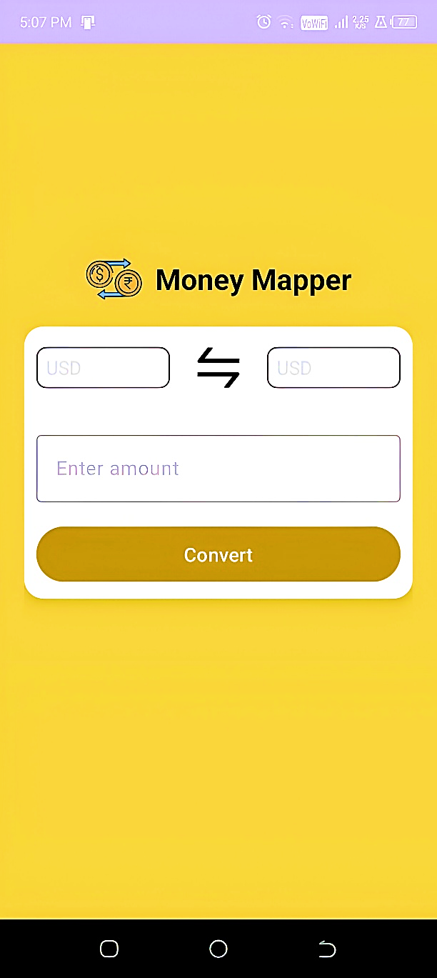

**Figure 1: Default Screen**

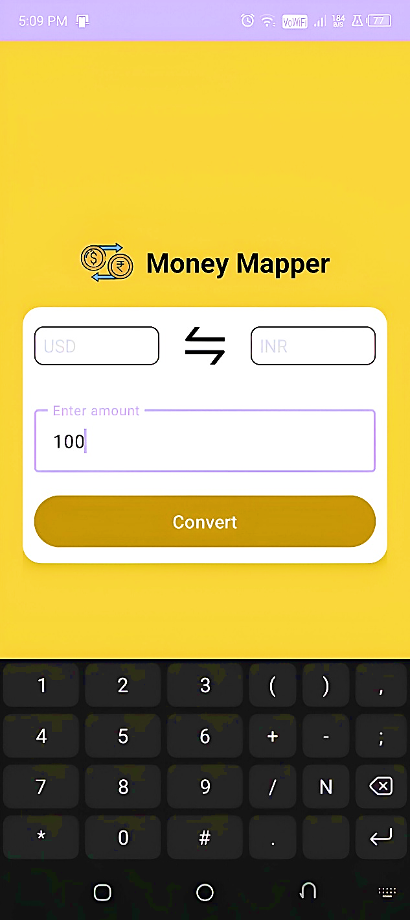

**Figure 2: Entering Amount**

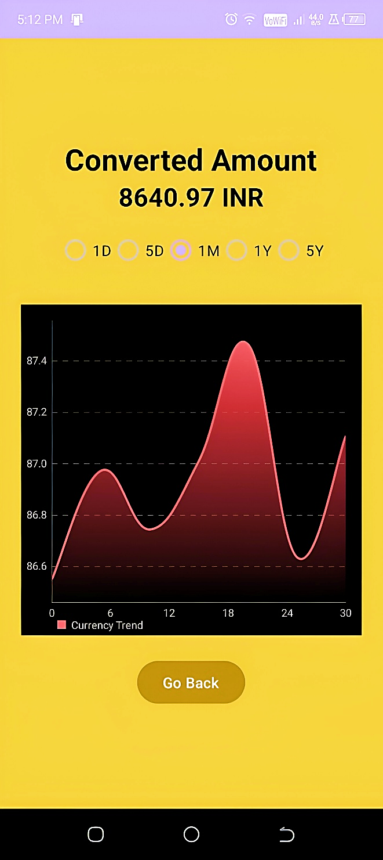

**Figure 3: Conversion with graph**